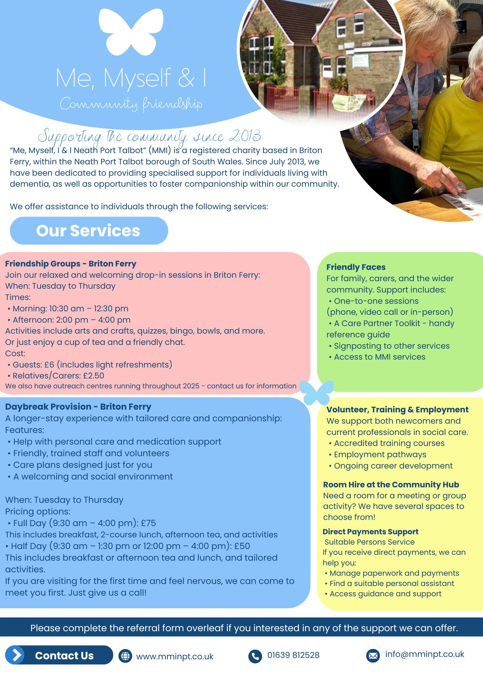

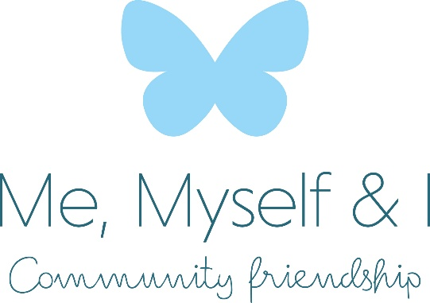

Referral Form

Services of Interest
Please tick the boxes below to indicate your interest and whether the service is for you or someone else.

Service Myself On behalf of someone
Friendship Groups Daybreak Provision Direct Payments Support Training & Employment Volunteer Opportunities Room Hire
Your Contact Information
First Name:
Address / Organisation:
Last Name:
Phone Number:
Email Address:
Your Relationship to the person (if referring someone):
If You Are Referring Someone Else Person's Name:
Known as:
Area Living:
Additional Information (e.g., mobility, personal care, medication needs):
Contact Us
www.mminpt.co.uk
01639 812528
info@mminpt.co.uk

